Snapshot 1 of code:

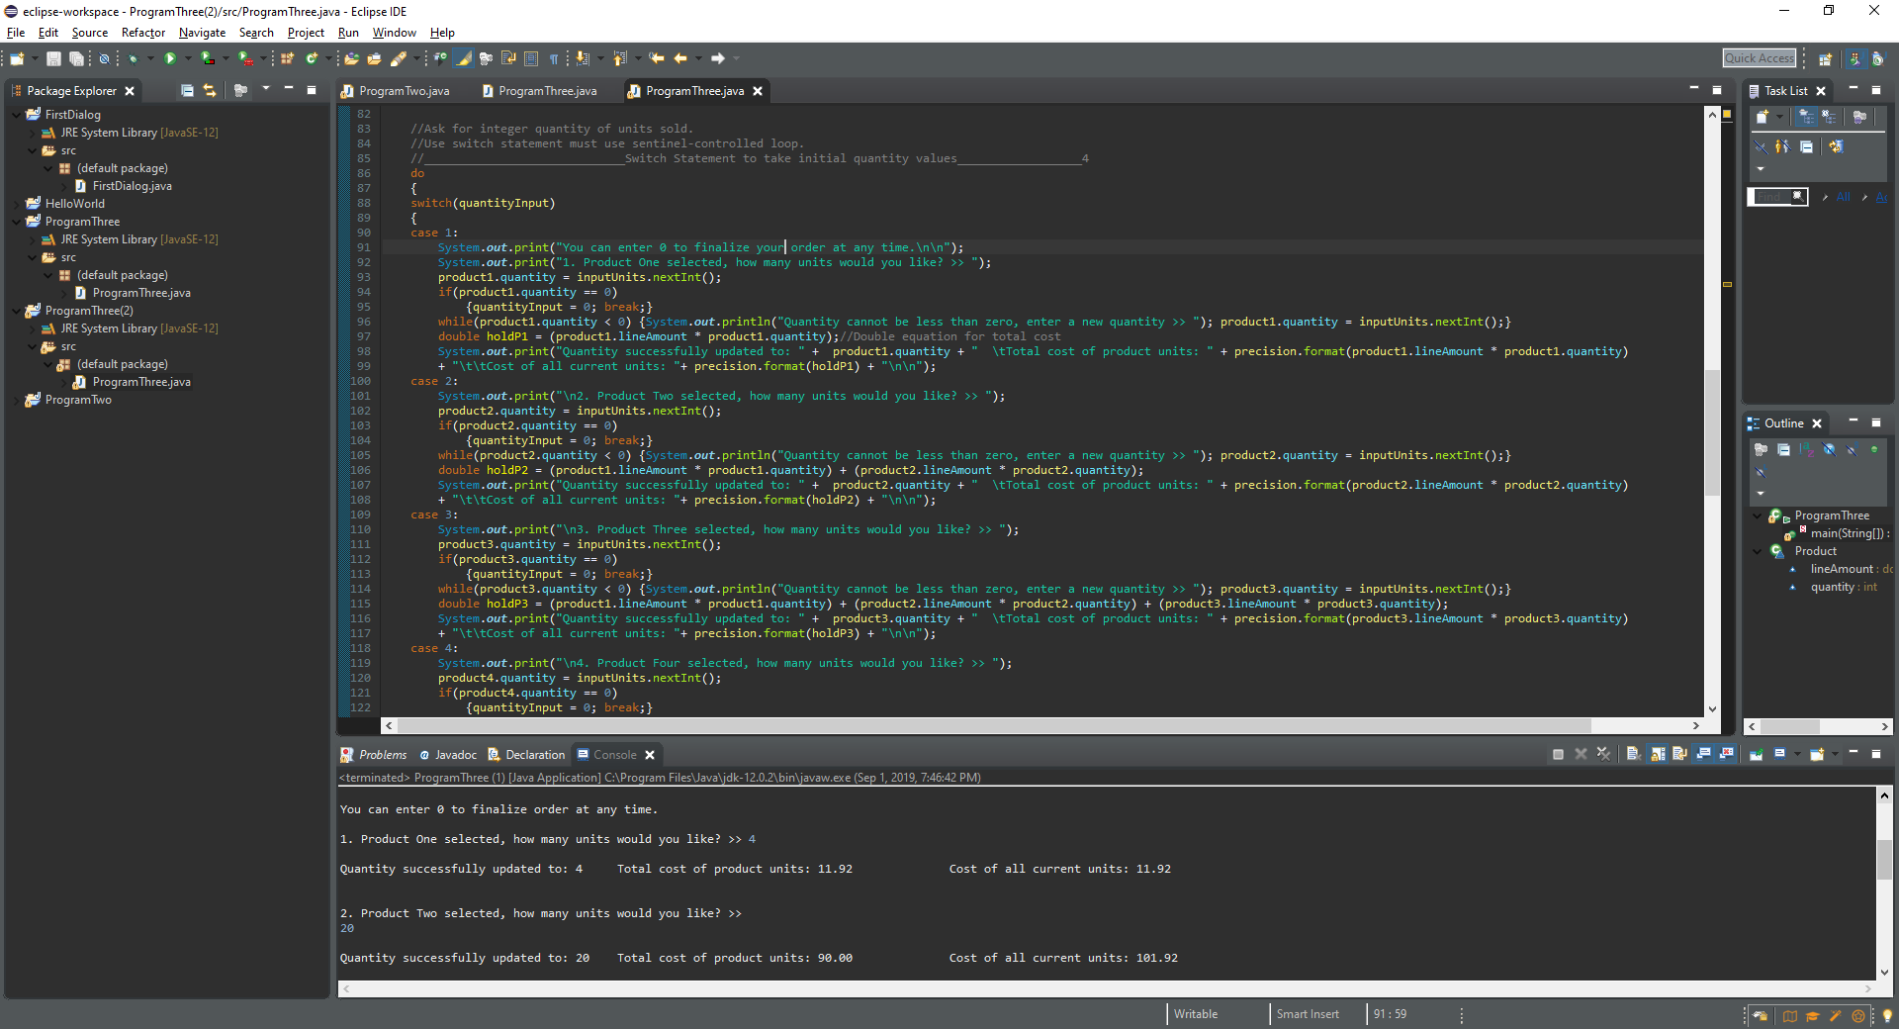

Code Output Snapshots:
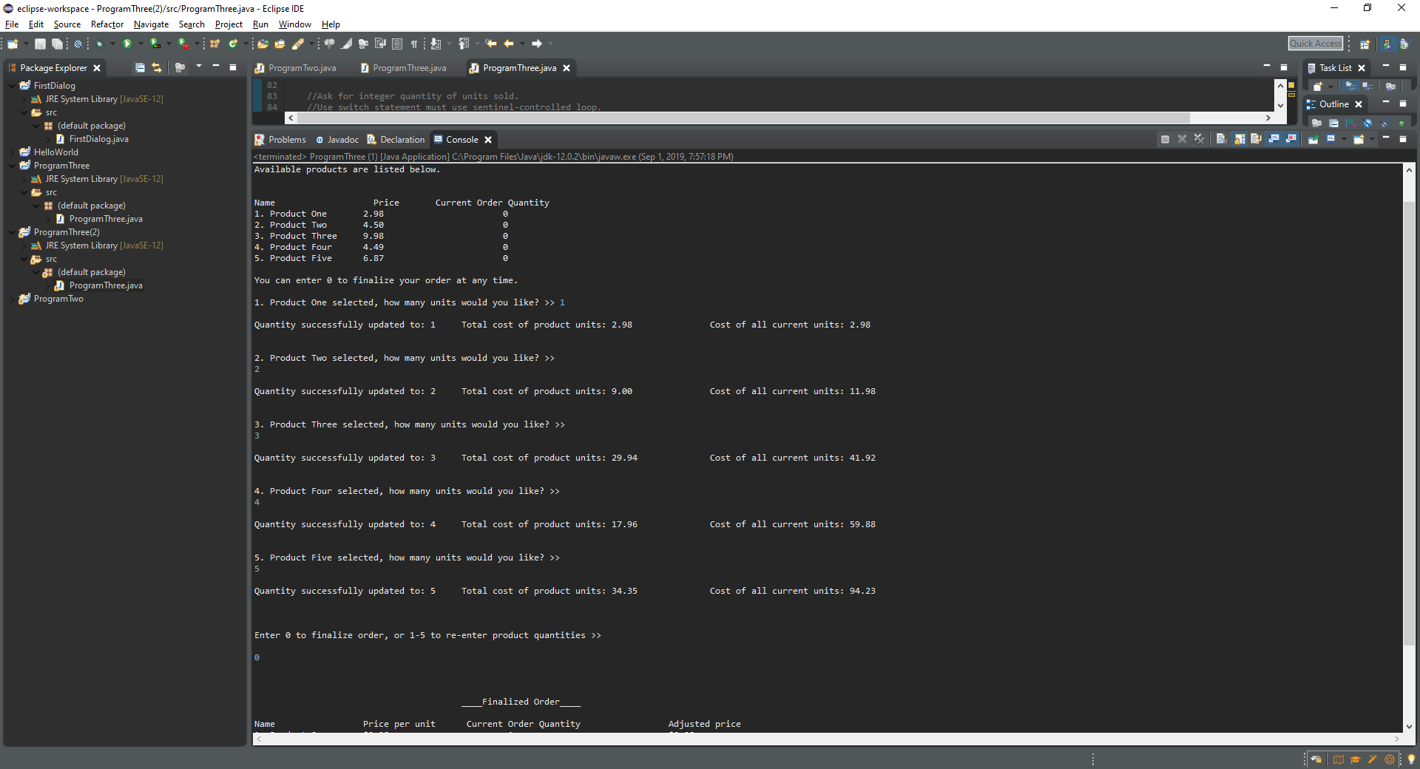
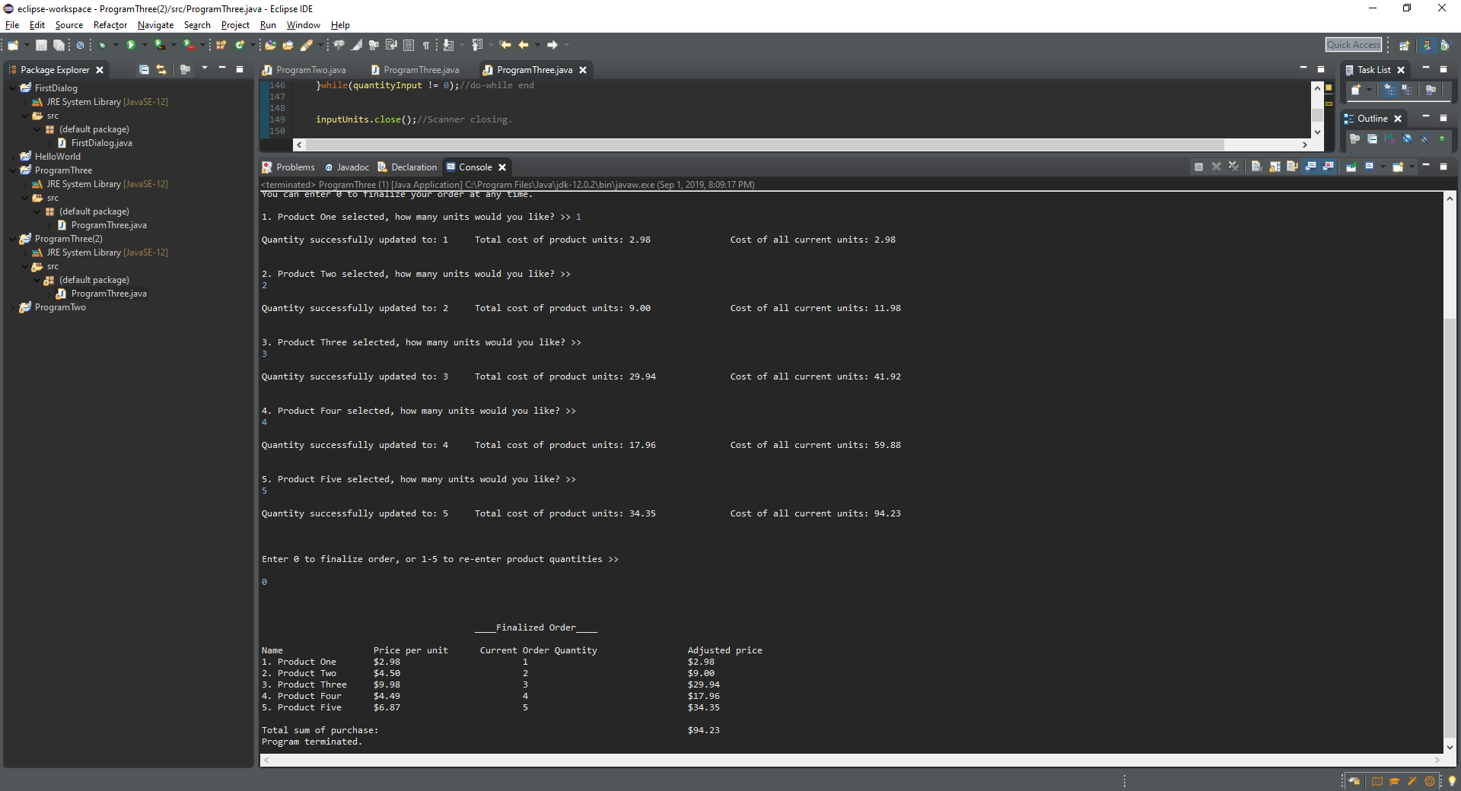

Below uses sentinel control number (0) to leave loop.
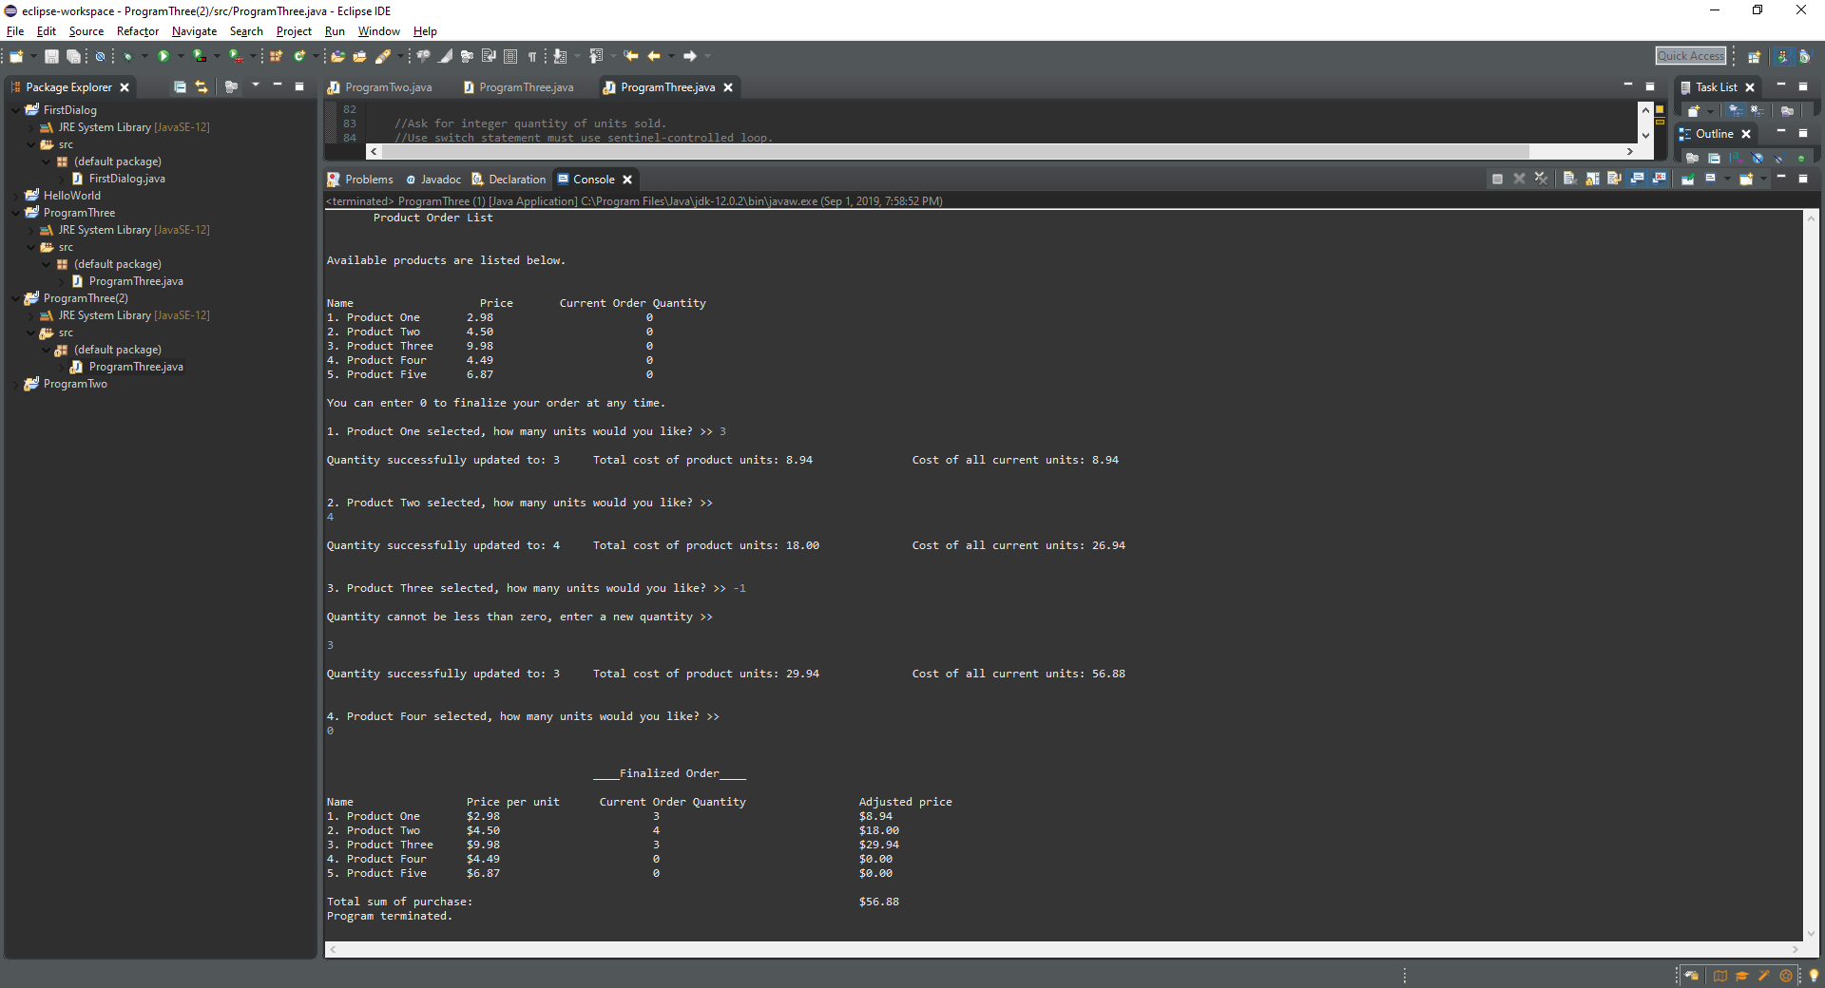

Uses the selection option to re-enter specific product quantities.
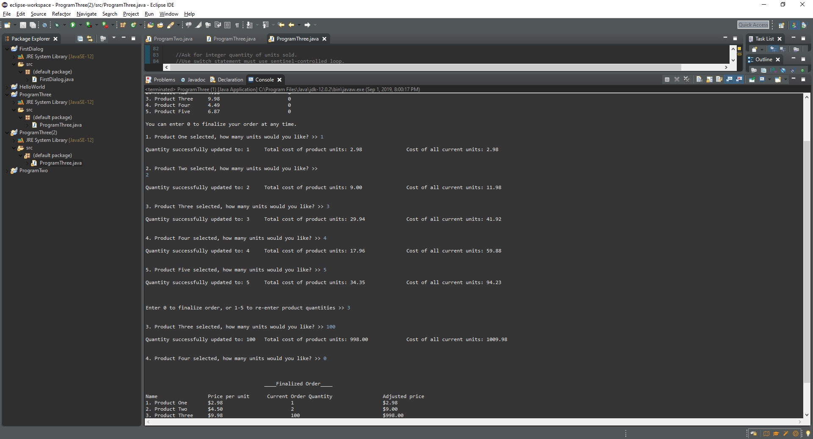

/*

Header
Program #3
Programmed By: Garrett Jones, student (August/30/2019)

Goal:

Write a Java Application that prompts the user for pairs of inputs of a product number(1-5), and then an integer quantity of units sold
(two separate prompts for input values). Must use a switch statement and a sentinel-controlled loop(i.e. loop that stops execution when an out of range value, such as -1 is input)
All 15 items are for a single purchase.

Product1 1 unit 2.98 per unit
Product2 2 units 4.50
product3 3 units 9.98
product4 4 units 4.49
product5 5 units 6.87

Specifications:
*Must show user input for each pair of product number and quantity, the calculated line cost for that product, and the cumulative order cost so far.
*Then, after the sentinel value is input your program must display the total retail cost for the full order.
*must show all 11 user inputs(5 product number and quantity pairs and the sentinel value) and all the corresponding program outputs, not just a subset of the
input and outputs.

*/

//__________________________Imports and Class definition___________________________________________1
import java.text.DecimalFormat;
import java.util.Scanner;

public class ProgramThree
{
public static void main(String[] args)
{
//_______________________Variable Declarations and Value Assignments___________________________2

Product product1 = new Product(); product1.lineAmount = 2.98; product1.quantity = 0;//creating product objects and assigning values.
Product product2 = new Product(); product2.lineAmount = 4.50; product2.quantity = 0;
Product product3 = new Product(); product3.lineAmount = 9.98; product3.quantity = 0;
Product product4 = new Product(); product4.lineAmount = 4.49; product4.quantity = 0;
Product product5 = new Product(); product5.lineAmount = 6.87; product5.quantity = 0;//1-5

DecimalFormat precision = new DecimalFormat("#0.00"); //creates a precision format for double values so that the full $ price will be shown.

int quantityInput = 1; //switch statement phase selection
int selection = 1; //default selection value
int stop = 0; //sentinel value

double totalSum;//Total sum of purchase.

Scanner inputUnits = new Scanner(System.in); //holds unit quantity

//___________________________Initial Information about products_________________________________3

System.out.println(" Product Order List\n\n");

System.out.println("Available products are listed below.\n");
System.out.print(
"\nName Price Current Order Quantity\n"
+"1. Product One " + precision.format(product1.lineAmount) + " " + product1.quantity//displays product information
+"\n2. Product Two " + precision.format(product2.lineAmount) + " " + product2.quantity
+"\n3. Product Three " + precision.format(product3.lineAmount) + " " + product3.quantity
+"\n4. Product Four " + precision.format(product4.lineAmount) + " " + product4.quantity
+"\n5. Product Five " + precision.format(product5.lineAmount) + " " + product5.quantity
+"\n\n");

//Ask for integer quantity of units sold.
//Use switch statement must use sentinel-controlled loop.
//_____________________________Switch Statement to take initial quantity values__________________4
do
{
switch(quantityInput)
{
case 1:
System.out.print("You can enter 0 to finalize your order at any time.\n\n");
System.out.print("1. Product One selected, how many units would you like? >> ");
product1.quantity = inputUnits.nextInt();
if(product1.quantity == 0)
{quantityInput = 0; break;}
while(product1.quantity < 0) {System.out.println("Quantity cannot be less than zero, enter a new quantity >> "); product1.quantity = inputUnits.nextInt();}
double holdP1 = (product1.lineAmount * product1.quantity);//Double equation for total cost
System.out.print("Quantity successfully updated to: " + product1.quantity + " \tTotal cost of product units: " + precision.format(product1.lineAmount * product1.quantity)
+ "\t\tCost of all current units: "+ precision.format(holdP1) + "\n\n");
case 2:
System.out.print("\n2. Product Two selected, how many units would you like? >> ");
product2.quantity = inputUnits.nextInt();
if(product2.quantity == 0)
{quantityInput = 0; break;}
while(product2.quantity < 0) {System.out.println("Quantity cannot be less than zero, enter a new quantity >> "); product2.quantity = inputUnits.nextInt();}
double holdP2 = (product1.lineAmount * product1.quantity) + (product2.lineAmount * product2.quantity);
System.out.print("Quantity successfully updated to: " + product2.quantity + " \tTotal cost of product units: " + precision.format(product2.lineAmount * product2.quantity)
+ "\t\tCost of all current units: "+ precision.format(holdP2) + "\n\n");
case 3:
System.out.print("\n3. Product Three selected, how many units would you like? >> ");
product3.quantity = inputUnits.nextInt();
if(product3.quantity == 0)
{quantityInput = 0; break;}
while(product3.quantity < 0) {System.out.println("Quantity cannot be less than zero, enter a new quantity >> "); product3.quantity = inputUnits.nextInt();}
double holdP3 = (product1.lineAmount * product1.quantity) + (product2.lineAmount * product2.quantity) + (product3.lineAmount * product3.quantity);
System.out.print("Quantity successfully updated to: " + product3.quantity + " \tTotal cost of product units: " + precision.format(product3.lineAmount * product3.quantity)
+ "\t\tCost of all current units: "+ precision.format(holdP3) + "\n\n");
case 4:
System.out.print("\n4. Product Four selected, how many units would you like? >> ");
product4.quantity = inputUnits.nextInt();
if(product4.quantity == 0)
{quantityInput = 0; break;}
while(product4.quantity < 0) {System.out.println("Quantity cannot be less than zero, enter a new quantity >> "); product4.quantity = inputUnits.nextInt();}
double holdP4 = (product1.lineAmount * product1.quantity) + (product2.lineAmount * product2.quantity) + (product3.lineAmount * product3.quantity)
+ (product4.lineAmount * product4.quantity);
System.out.print("Quantity successfully updated to: " + product4.quantity + " \tTotal cost of product units: " + precision.format(product4.lineAmount * product4.quantity)
+ "\t\tCost of all current units: "+ precision.format(holdP4) + "\n\n");
case 5:
System.out.print("\n5. Product Five selected, how many units would you like? >> ");
product5.quantity = inputUnits.nextInt();
if(product5.quantity == 0)
{quantityInput = 0; break;}
while(product5.quantity < 0) {System.out.println("Quantity cannot be less than zero, enter a new quantity >> "); product5.quantity = inputUnits.nextInt();}
double holdP5 = (product1.lineAmount * product1.quantity) + (product2.lineAmount * product2.quantity) + (product3.lineAmount * product3.quantity)
+ (product4.lineAmount * product4.quantity) + (product5.lineAmount * product5.quantity);
System.out.print("Quantity successfully updated to: " + product5.quantity + " \tTotal cost of product units: " + precision.format(product5.lineAmount * product5.quantity)
+ "\t\tCost of all current units: "+ precision.format(holdP5) + "\n\n");
case 6:
System.out.print("\n\nEnter 0 to finalize order, or 1-5 to re-enter product quantities >> ");
quantityInput = inputUnits.nextInt();
break;
default:
System.out.println("Invalid input.");
break;
}//switch end
}while(quantityInput != 0);//do-while end

inputUnits.close();//Scanner closing.

totalSum = (product1.lineAmount * product1.quantity) + (product2.lineAmount * product2.quantity)
+ (product3.lineAmount * product3.quantity) + (product4.lineAmount * product4.quantity) + (product5.lineAmount * product5.quantity);

//_____________________________Finalization_________________________5

System.out.println("\n\n ____Finalized Order____");
System.out.print(
"\nName Price per unit Current Order Quantity Adjusted price\n"
+"1. Product One $" + precision.format(product1.lineAmount) + " " + product1.quantity + " $" + precision.format(product1.lineAmount * product1.quantity)
+"\n2. Product Two $" + precision.format(product2.lineAmount) + " " + product2.quantity + " $" + precision.format(product2.lineAmount * product2.quantity)
+"\n3. Product Three $" + precision.format(product3.lineAmount) + " " + product3.quantity + " $" + precision.format(product3.lineAmount * product3.quantity)
+"\n4. Product Four $" + precision.format(product4.lineAmount) + " " + product4.quantity + " $" + precision.format(product4.lineAmount * product4.quantity)
+"\n5. Product Five $" + precision.format(product5.lineAmount) + " " + product5.quantity + " $" + precision.format(product5.lineAmount * product5.quantity)
+ "\n\nTotal sum of purchase: $" + precision.format(totalSum));
System.out.println("\nProgram terminated.");
System.exit(stop);
}//main
}//P3

//_______________________Product object creation_________________________6
class Product
{
double lineAmount;
int quantity;

}//product end

